No. | INSTRUCTIONS |  | KEY POINTS / CONTACTS
1. | Measure the distance between the side guides and then check the distance indicated on the LOP.  If there is a difference, calibrate the guides so that the distances are the same. | 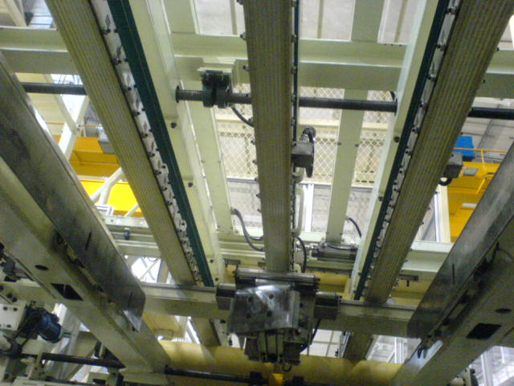 | ENSURE PERSONNAL PROTECTIVE EQUIPMENT (PPE) IS WORN: -  1. HARD HAT  2. STEEL CAP BOOTS  3. GLOVES  ENSURE LOCK- OUTS AND SAFETY BLOCKS ARE USED AT ALL TIMES.

